# Update and upgrade Linux
sudo apt update && sudo apt upgrade -y
# download splunk
wget -O splunk-10.0.2-e2d18b4767e9-linux-amd64.deb "https://download.splunk.com/products/splunk/releases/10.0.2/linux/splunk-10.0.2-e2d18b4767e9-linux-amd64.deb"
# Install Splunk
dpkg -i splunk_package_name.deb
#commands for showing installation status
#Splunk package status:
dpkg --status splunk
# If installed successfully should show up like the image below
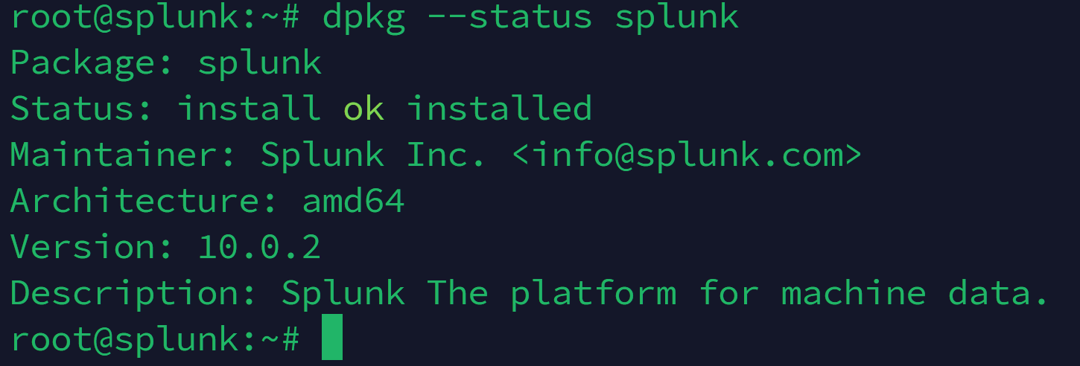

#Start Splunk
cd /opt/splunk/bin
./splunk start
#if started it will show output like this
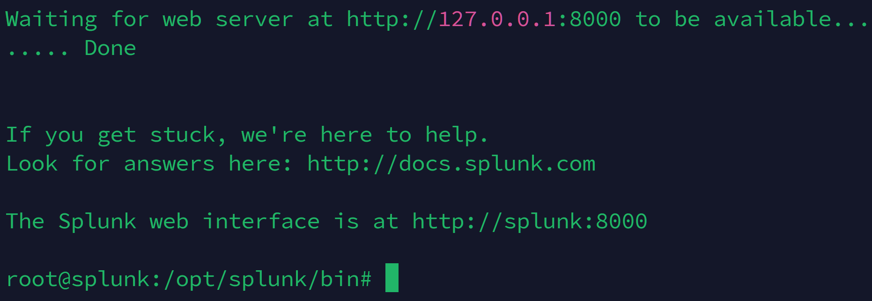

#To make splunk interface accessible from other networks
./splunk stop
cd /opt/splunk/etc
nano splunk-launch.conf
#Add “SPLUNK_BINDIP=0.0.0.0” here:
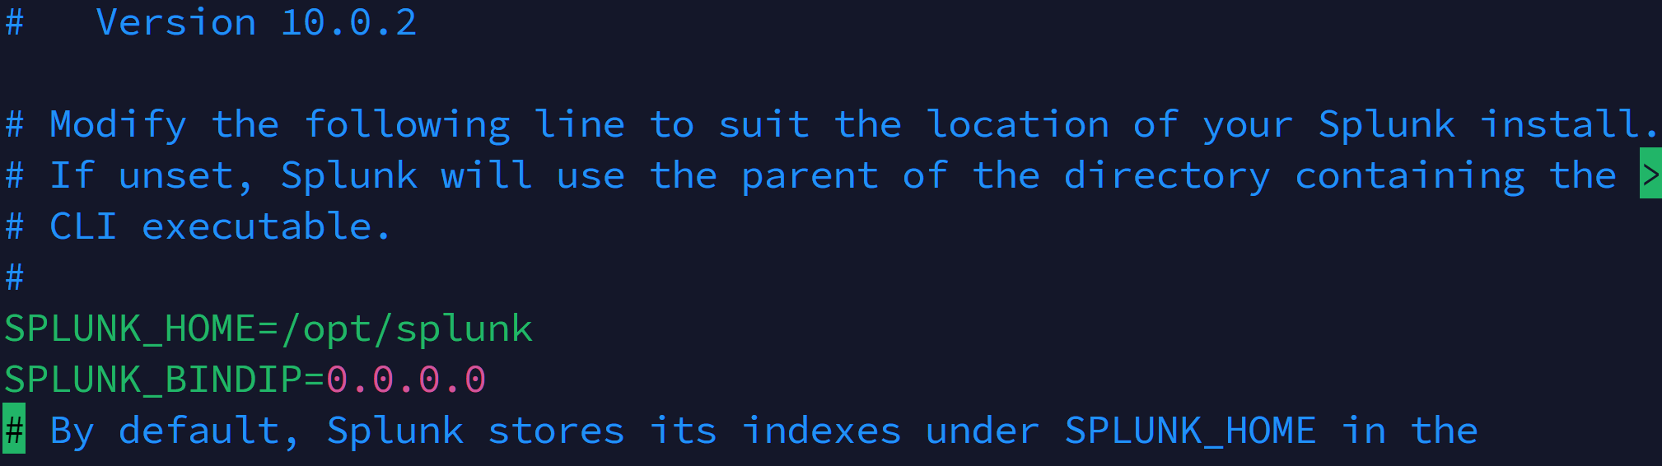
#Go to splunk home directory and start splunk again
cd /opt/splunk/bin
./splunk start
#To access the splunk interface find the machine ip and access it on port 8000
http://<SPLUNK_MACHINE_IP>:8000
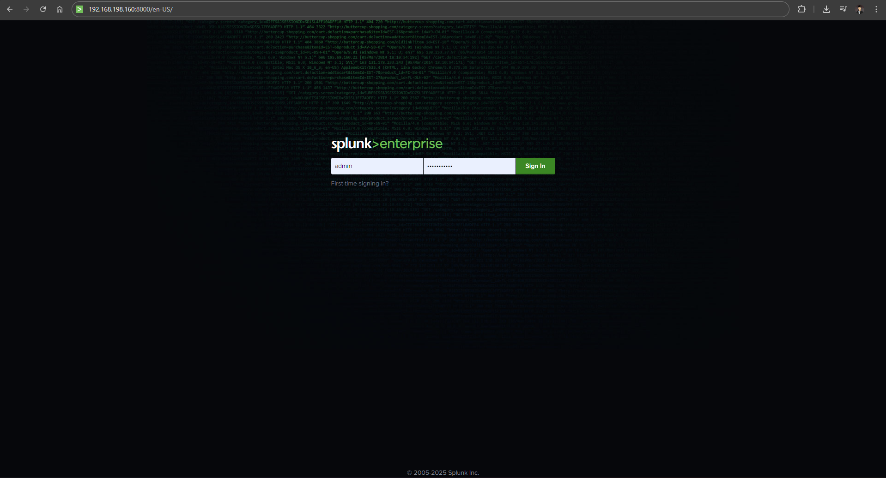
#Enable splunk to start on boot
./splunk enable boot-start
